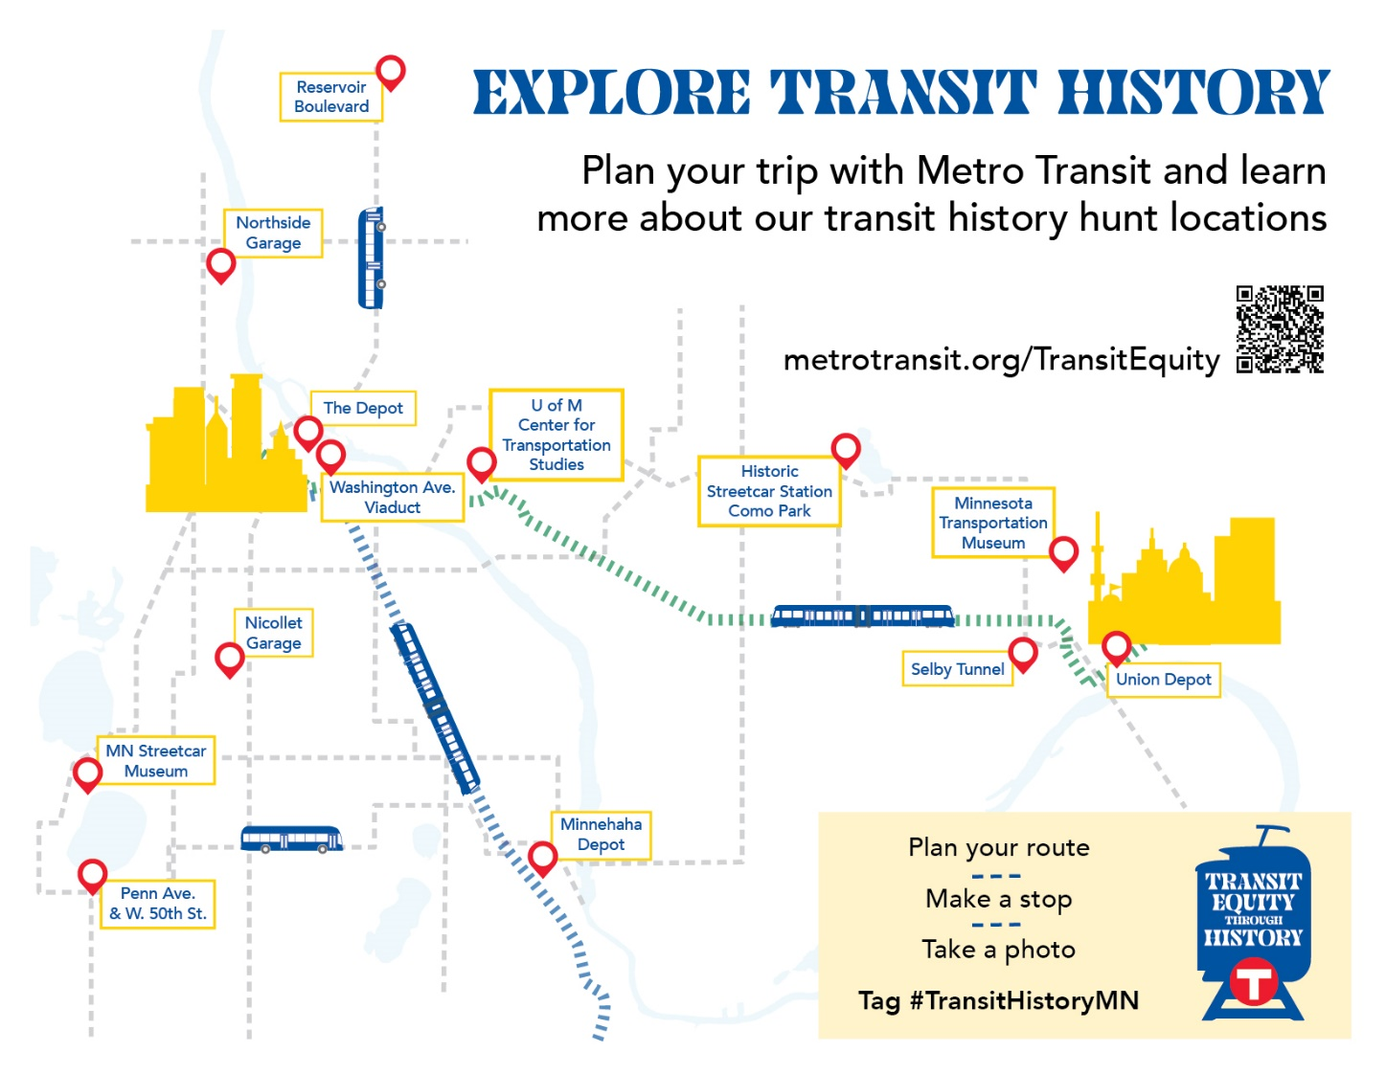

Find your #TransitHistoryMN
50th and Penn Ave | Accessible via Routes 4 or 46  Street looks the way it does because it was a streetcar terminal and still looks this way. Stand at SE corner by Sparrow Café. Look across 50th street. Penn Ave is wider for about 100ft and then narrows.
Center for Transportation Studies  University of Minnesota  University Office Plaza, Suite 440  2221 University Avenue SE  Minneapolis, MN 55414 | Accessible via Green Line  The Center for Transportation Studies (CTS) is the hub for transportation research and education at the University of Minnesota. It supports research in many disciplines, cultivates the transportation workforce, and shares new thinking with various stakeholders and audiences.  CTS was established in 1987 to meet a need for greater connection between the state’s transportation agencies and University researchers. That underlying goal—applying U of M thinking to solve real-world issues—still drives CTS today”
Como Park Streetcar Station  1224 N Lexington Pkwy, St Paul, MN 55103 | Accessible via routes 3 and 83.  Como Park is one of the great features of this city and has always contributed to the quality of life for all residents, regardless of their economic status or race. The beautiful streetcar waiting station was constructed in 1904 and is a monument to the commitment by the city and streetcar company leaders to Saint Paul and Minneapolis, not only the affluent neighborhood by the park. This is about high-quality park access for everyone. The historic transit investment is one reason why frequent bus service continues nearby now and upgraded service is being planned in the future.
Minnehaha Park Railroad Station  Minnehaha Park Hwy 55 & Minnehaha Parkway Minneapolis, MN 55417 | Accessible via METRO Blue Line.  You are looking at a very unique historic building. This depot- nicknamed the “Princess”, dates from the late 19th century and its local trains served the residents already present to the west for their commutes to downtown Minneapolis, and to many points south and east, even to Chicago. Several of our suburbs and city neighborhoods were first offered public transportation via steam powered local trains at stations similar. When Twin City Lines extended electric streetcar service here in the early 20th century, the frequent daily service attracted most of the riders away from the Milwaukee Road local trains and the transition was complete by about 1915. Today, access for all people to parks of regional significance remains an important goal for the Metropolitan Council. Minnehaha Park is one of the best examples of where this has been achieved consistently for over 130 years, via local trains in the 19th century to the Minnehaha Ave streetcar thru the first half of the 20th century, then via the buses and most notably with the introduction of the trains of the METRO Blue Line in 2004.
Minnesota Streetcar Museum  Como-Harriet Streetcar Line  2330 West 42nd Street, Minneapolis, MN 55410 | The Minnesota Streetcar Museum runs two streetcar lines in Minneapolis and Excelsior, MN. Enjoy a trolley trip along a half-mile of track built on the former right-of-way of the Minneapolis and St. Louis Railway. The car makes a stop at our carbarn so passengers can view a photo gallery of hotels, trains, paddlewheel boats and landmarks from the 1800s and see work in progress on a streetcar restoration.
Minnesota Transportation Museum  193 Pennsylvania Ave, St. Paul, MN, 55130 | The Minnesota Transportation Museum (MTM) is located at the historic Jackson Street Roundhouse. This building was originally a steam engine maintenance facility for The Great Northern Railroad.
Nicollet Garage  10 West 32nd Street,  Minneapolis | Nicollet Garage is located southwest of the Lake Street and Nicollet Avenue intersection, in the Lyndale neighborhood. This is the most urban setting of any Metro Transit garage. The facility is built to limit impacts on surrounding property owners. Administrators and other Metro Transit staff were based at Nicollet Garage until Heywood Garage opened in 1984. In 1991, the garage was rebuilt, replacing a turn-of-the-century facility that housed streetcars and was converted to bus use in 1953. Today there are around 150 buses at the Nicollet Garage that primarily provide urban local service in Minneapolis.
Northside Garage  Washington Ave and 24th Ave N, Minneapolis | Accessible via routes 14 and 30  Twin City Lines built Northside to standard plans of their own design and made many of their own construction materials. They called streetcar operating bases “stations”. Northside dates from 1915 and was the operating base for most of the service provided in north Minneapolis until it was replaced by the Metro Transit Heywood Garage at 7th St and 6th Ave N in 1984. North Minneapolis has been one of the most diverse parts of the city for most of its existence, with many immigrant-working class residents. At first, there were many Jewish and Eastern Europeans, then after mid-century, many African Americans. High frequency, reliable transit via streetcar and bus was provided for the north siders very effectively from this location. This facility and Heywood Garage today make equitable transportation possible in north Minneapolis.
Reservoir Boulevard  3701 Central Ave NE, Columbia Heights, MN 55421  3701 Reservoir Blvd - Google Maps | Columbia Heights was once home to streetcars from 1893 to 1951. One streetcar line came into Columbia Heights via Central Avenue and then turned onto 40th and ran down to 5th street. Another streetcar line turned onto Reservoir Blvd and traveled north to the Minneapolis Filtration Plant. A five-cent fare was the cost of a streetcar ride. Before the 1890s, streetcars were powered by horses and mules, and the grassy slopes of Columbia Heights provided pasture for many of the animals which pulled streetcars in Minneapolis.
Selby Subway Subway Tunnel  Kellogg Blvd near Pleasant Ave, Saint Paul. | Accessible via Route 21 and close to most downtown routes.  The neighborhood at the top of the hill developed early in the history of this city - but creating access via this 16% grade was not easy. Direct service was first provided by cable cars (think San Francisco). In the early 20th century, Twin City Lines had a better idea: build a tunnel or streetcar subway under the hill to achieve a manageable, 7% grade for electric streetcars to travel. It was very expensive and required about two years to construct. When it was complete, it provided reliable high frequency transit on Selby Ave and via a long route that extended across Lake St thru the south side of Minneapolis. The neighborhoods along Selby Ave were, and are more diverse than, say, the parallel and more affluent Summit Ave. The traditional African American community along Rondo Ave ran parallel to the north until most of it was removed for I-94 in the 1960s. While Rondo Ave had its own transit line, many residents walked the blocks south to the high frequency Selby Ave line. This major investment in transit provided equitable access to a very diverse population. The tunnel was closed and the upper portal at Nina St covered over after the buses replaced the streetcars in 1953. Even so, the Selby Ave Subway's influence on the shape of the city continues in the frequent Metro Transit Route 21 and the planned high frequency Bus Rapid Transit B Line coming by mid-decade.
The Depot  500 Washington Ave. S.  Minneapolis, MN 55415 | “The rail line, first built in 1864, was originally known as the Minnesota Central Railroad. In 1867 the Milwaukee and St. Paul Railroad bought the Minnesota Central Railway, changing the name of the railroad to the Chicago, Milwaukee and St. Paul Railroad in 1874 before shortening the name to Milwaukee Road. The old Milwaukee Road Depot was constructed in 1899 and remains one of the last long-span, truss-roofed sheds surviving in the nation”
Washington Ave viaduct between 5th Ave & Chicago Ave S. | METRO Blue Line, Routes 3 and 22 directly serve this location.  The white stone retaining wall has been preserved at the SW corner of Washington at Chicago. Present day METRO Blue Line operates largely on the right of way the Milwaukee Road Passenger train used between Lake Street and Downtown East.

